*Learn how to drive in Nova Scotia*

*(Nova Driving)*



Final Report

Group members

Robert Spasyou A00437899

Munmun Manna A00433445

Bijay Khadka A00437343

Yilong Wu A00429725

Ashit Poddar A0043329

**Group members**

Yilong Wu (A00429725)

Ashit Poddar (A00433298)

Munmun Manna (A00433445)

Bijay Khadka (A00437343)

Robert Spasyouti (A00437899)

Contents

Executive summary and conclusion 4

Project description and goals 5

The motivation of the project 5

Requirement gathering 6

User survey 6

Survey questions and logic 6

Survey results 7

Outcomes of the Design Thinking Workshop 8

Persona description 8

Empathy map 8

As-Is Scenario 9

Mapping ideas based on feasibility and pain points 9

Design progression and requirement 10

Requirement formulation and refinement 11

User and interface requirements 11

Functional requirements grouping 12

Paper prototyping and heuristic evaluation 13

Final design 14

Usability study design 15

Study design goals and objectives 15

Methodology 16

Test plan 17

Analysis results and discussion 18

Results of usability testing 18

Category – Efficiency 19

1. Login vs Home 19

2. Remaining test and summary 21

Summary and Future work 22

References 23

Appendices 24

Appendix A – Design Thinking Workshop 25

Empathy results 25

Summary of needs 26

Appendix B – Detailed functional requirements and heuristics 27

Group 1: Functional requirements 27

Group 2A: Lessons functional requirements 30

Group 2B: Tests functional requirements 31

Group 2C: Resources functional requirements 33

Heuristic evaluation results summary 34

Logical Process Flow 35

Appendix C - Usability testing details 36

Test method specifics 36

Test scenarios and cases 37

Data analysis plan 38

Test script 38

Appendix D – Usability Test Results 40

2. Home vs Lessons 40

3. Login vs Lesson 40

4. Lessons vs Test 41

5. Home vs Test 41

6. Login vs Test 42

7. Test vs Resources 42

8. Lessons vs Resources 43

9. Home vs Resources 43

Category – Dependency 44

Category - Uniformity 46

# Executive summary and conclusion

Relocating to a new country can be truly be bittersweet, it presents a myriad of new cultures and people to meet, languages to learn and speak, places to see and explore, and wholesome new experiences and adventures. With these new experiences comes some challenges tied to …

According to Statistics Canada, in 2016 Nova Scotia alone was home to 14,063 international students, a number that has grown 2.7% more from the previous year. To some of these students navigating a new place takes time to get used to, while driving in a new place requires quiet a bit more. Road rules could be different, weather conditions could be new and the licensing process is just another matter to add to the list.

Nova Driving – a name rooted in its purpose. The word ‘Nova’ in Latin means ‘New’ – which is what is used to describe the *new* driving skills that are needed to be learned by the *newcomers* to a Province they are calling their *new* home.

The purpose was born due to the lack of a platform that addresses the user needs and includes the key features which were iteratively refined with each part of the design process. Following the Design Thinking process, our team harnessed our creative energies and focused them on our problem statement. After spending time understanding, exploring and materializing - the design took shape into a prototype and design solution that was user-centric and problem-focused.

Creating a design that was simple, straight-forward, user- and language-friendly were critical requirements and design principles that were engrained within our team vision from the early stages. Therefore, the various features of our platform were tested using a detailed usability testing plan and protocols that were then further statistically analyzed to help us assess the design’s efficiency, dependency and uniformity. Although improvements and further developments are planned for the next phase of work, our design has successfully included all the major components and features that address the needs of our target audience and yield favorable usability testing results.

# Project description and goals

## The motivation of the project

The motivation behind Nova Driving is to design a mobile app with friendly environment for the people who are trying to learn driving in Nova Scotia, preparing for the driving license test and/or who lack the necessary driving experience and skills in different road and weather conditions. An additional key ingredient is our commitment to our user group’s need of helping bridge the language gap of new comers to the Province by offering non-English language options. In summary the solution will be design in accordance with the following user needs in mind:

* Language-friendly with multiple options to appeal to a wider audience of new comers
* Simple and straightforward instructions, content and materials
* Easy to navigate design across the app’s features and settings
* Assist with test preparation and education
* Local focus: Road rules and regulations of Nova Scotia
* Provide additional resources and materials
* Enhance the learning experience

Applying the Design Thinking process as outlined in Figure 1 by Gibbons from the NN Group (2016), our team followed the iterative process underpinned by our design principles to explore user needs and requirements to designing and testing a user prototype before leading into the next phase of full-scale development.

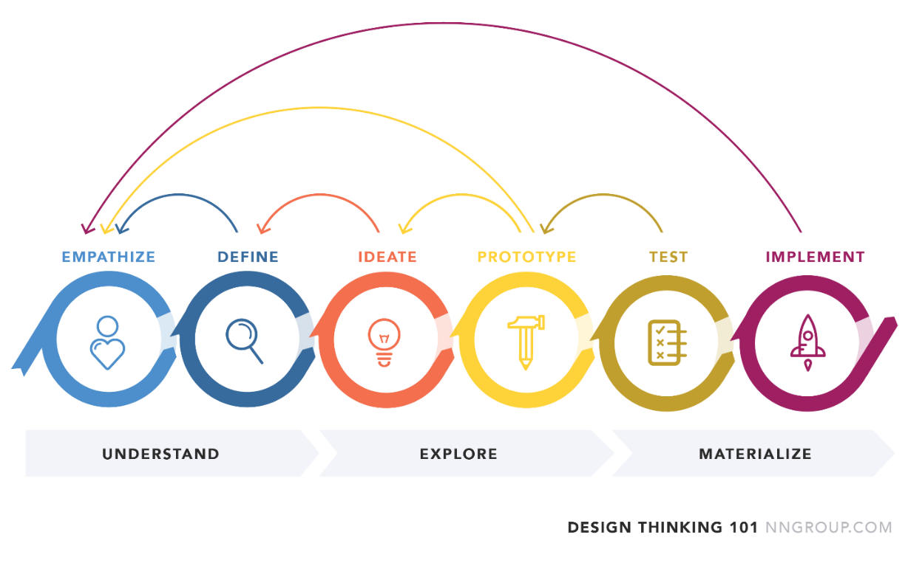

Figure : Design Thinking Process

# Requirement gathering

The requirement gathering process consisted of three elements:

1. 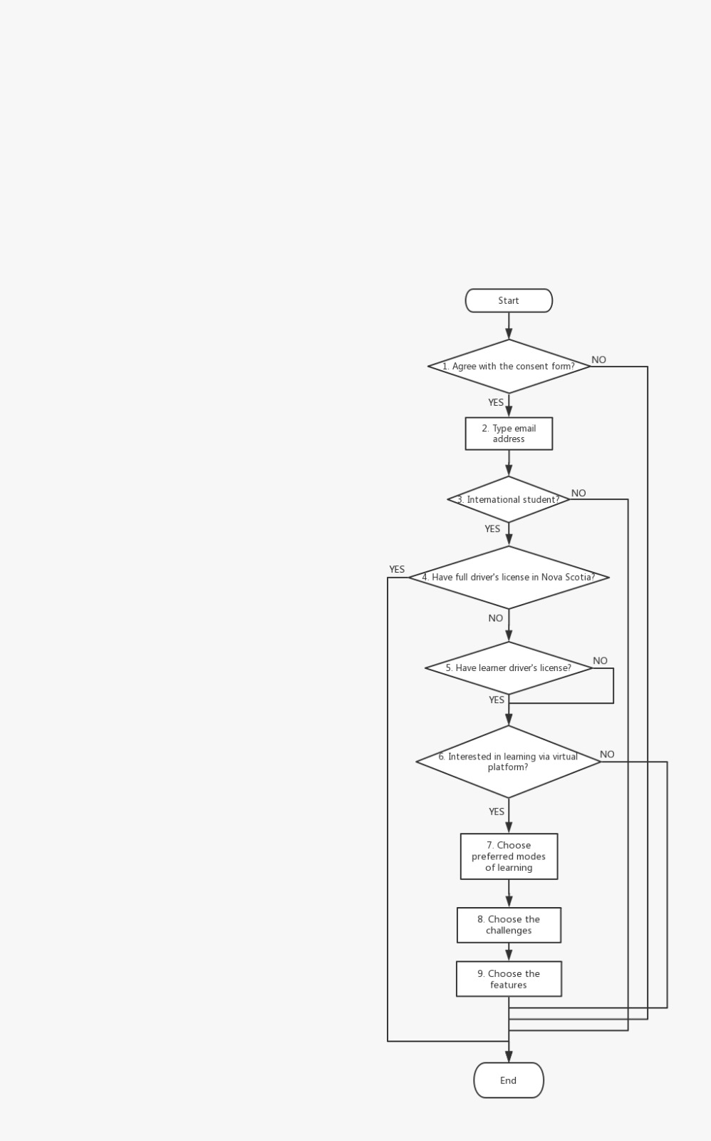Design and deployment of a user survey to gather and analyze user needs to focus the design process on the most necessary features

Figure : User Survey Logic Flow

1. Knowledge and data gathered from secondary research into the market; a scan of the application and gaming already in the market

## 

## User survey

### Survey questions and logic

To better understand the challenges of our user group and the potential features of interest, our study had solicited feedback, ideas and gathered the necessary user requirements to design a need-based and user-centric solution. The method of gathering information on our user group and their interests is through an online survey.

The table below lists the questions used in the survey and the rationale and information each question aims to collect. The diagram to the right depicts the logical flow of questions.

### Survey results

The first set of questions aims to ensure our study identifies our user base and excludes any unusable responses that may have not been captured through the logical survey flow. From the total number of 33 survey response, only 23 (70%) are considered usable based on the following conditions:

* International students
* Interest in learning to drive in Nova Scotia using a virtual platform

Study population stratification was attempted based on the respondent’s current licensing characteristics. Majority of our study population (87%) does not have a full driving license or a learner permit to drive in Nova Scotia.

The charts represent the preferred mode of learning, highlight the key and most revenant user challenges and the solution features that best fit our study population’s needs and wants, respectively. The dark blue bar in each chart represents the highest voted response from each domain. Next design iterations and workshops and specifically the proposed design sketches will focus on the modes, challenges and features mined from the study.

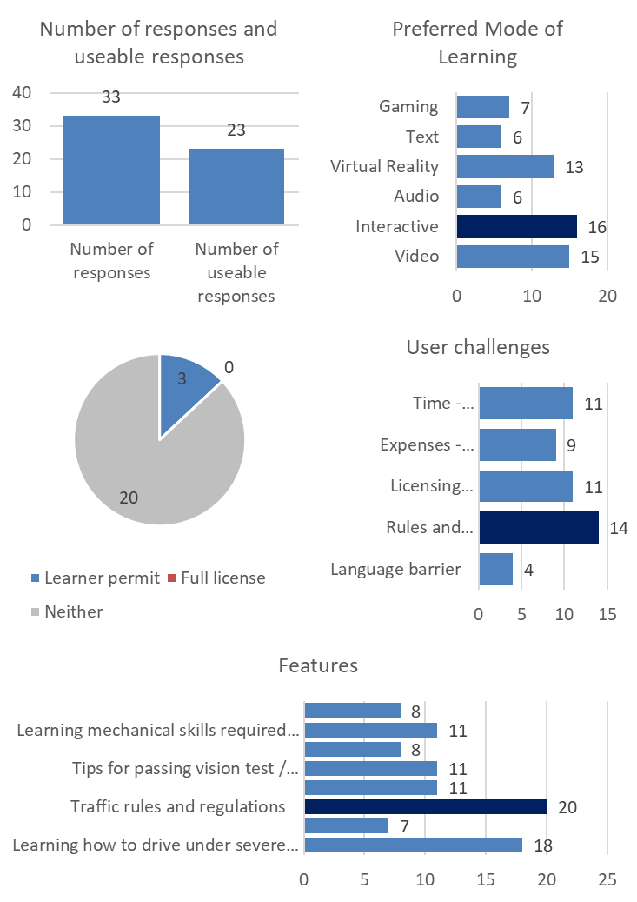



Table : User Survey Questions

Figure : User Survey Analysis Results

## Outcomes of the Design Thinking Workshop

## 

Figure : Persona Brainstorming Results

Our persona ‘Newbie’ is a 27-year-old originally from the Bahamas, currently living and studying in Halifax, Nova Scotia. His personal interests include drinking rum, long walk by the Halifax harbour, exploring nature and different places. He lives a relatedly healthy lifestyle and frequents the gym. His other interests include getting piercing and tattoos.

His hobbies are to play badminton, collect toy cars, listening to music and playing mini golf. While his fears are driving at night and bad weather condition specifically during snowstorms. He hates to travel using public transit and especially buses due to the long waits, congestion and waiting in cold weather. His preferred mode of transport is as a solo traveller.

He wants to learn how to drive and gain a better understanding of Nova Scotia’s driving rules and regulations. He wants to pass the written and driving exam. Further to that, he wants to figure out and gain more confidence in how to drive in icy and snowy condition along with that he wants to overcome the language barrier and wants to gain handy skills (e.g. changing a tire).

### Empathy map

Table : Empathy Map Elements

|  |  |
| --- | --- |
| **Say** (The phrases and quotes that Newbie would say regularly) | **Think** (The various thoughts and matters that grab Newbie’s attention) |
| **Do** (captures Newbie’s actions) | **Feel** (Feeling and inner emotional reactions to specific experiences and things) |

Figure : As-Is Scenario Formulation

The AS-IS Scenario was created using the results of the empathy map. It shows what steps Newbie is doing, thinking and feeling while he is completing the key steps:

* Commute back and forth from work or other places
* Social+ recreational activities that he engages in on daily or weekly basis
* Planning activities for getting a license, gathering the necessary materials to study, learn and navigate the system and licensing process
* Completing is daily work and study tasks

### A close up of a sign Description automatically generatedMapping ideas based on feasibility and pain points

**No-Brainers:**

* Mock Driving Exams (to help prepare, build confidence)
* Show various winter driving scenarios and how to handle and manage the situation safely
* Rules & regulation materials (specific to NS) in multiple languages
* Provide list of resources for all/most driving /licensing needs and handy skills

**Utilities:**

* Breakdown the costs and expenses related to preparing and get the license
* Visually represent the licensing process (in multiple languages) to simplify the process

Figure : Prioritization of requirements and user needs

* Memory games and other modes to learn rules and regulations interactively

**Big-Bets:**

* Check weather forecast during winter
* Communicate in English

# Design progression and requirement

The following summary outlines the major elements of the design that were taken into the detailed requirement formulation stage.

|  |  |
| --- | --- |
| **Expense & Budget** | Breaks down the costs, and expenses (Budget adjustment)  Gets a job to take care of your expenditure |
| **Resources** | Video library of skills and required information  Mock driving exams (to help preparation, and build confidence)  Shows various winter driving scenarios, and how to handle & manage the situation safely  Video instruction on handy skills or severe weather conditions |
| **Language** | Communicates in English  Translation |
| **Human Resources** | Public transit supplementary  Explores places which is reachable through transit  Finds a friend who has car and can drive, and make him BFF  Carpool |
| **Winter** | Checks the weather forecast during winter  Try putting slip less tires in winter so that the car grasp well in snow |
| **DMW website & Licenses** | Navigation for online websites  Demo for Nova Scotia DMV website  Info navigation and simplify  Visual represent the licensing process  Provides a user-friendly and inexpensive way to prepare, and get a license in Nova Scotia |
| **Rules & Regulations** | Teaches them Rules & Regulations  Games/Interactive to learn the rules & Regulations  Rules &Regulations materials in multiple languages  Ask a friend which method he/she used to know the driving rules & regulations |
| **External Resources** | Provides cost of resources for all/most driving / licensing needs  List of driving schools  Compare different driving courses, and find the review of each courses from different people  Online courses |

Table : Summary of major design components

## Requirement formulation and refinement

Based on the Design Thinking Workshop, online survey results and the requirement gathering process - the purpose of the Nova Driving learning platform has been refined and summarized as follows:

* Provide the necessary learning requirements to prepare the user for the different gates within the licensing process including the written and driven tests
* Provide an accessible learning experience through adjustable language preferences
* Provide the right level of information in a simplified, visual and interactive manner to help users understand and navigate the licensing process with a local frame of reference
* Provide lessons and learning materials in a visually interactive manner to teach users about driving in Nova Scotia outside what is covered in the local written and driven tests
* Provide resources for the user for additional support and learning

## User and interface requirements

**User (U) requirements:** are defined based on the needs and pain points of the primary user group (international students in Nova Scotia) defined as part of the Design Thinking Workshop in addition to the user survey results.

1. Interactive and dynamic content
2. Language settings and preferences
3. Account registration
4. Progress tracking
5. Simple and clear language and wording

**User Interface (UI) requirements:** are defined based on … and will function as the design principle of the prototype and ultimately the developed solution.

1. Conciseness: segment and divide information into sections to reduce cyclic navigation, scrolling and reference linkage
2. Minimize the number of clicks
3. Descriptive icons and buttons
4. Consistent and simple layout

## Functional requirements grouping

The functional requirements are divided into two main groups which are listed below. Group 1 describes the system and general process requirements of how the system operates. Group 2 describes the three (3) features of the system and outline how each feature operates. Figure 1 shows the logical process flow of the system and how each screen, function and feature flows into and across each other.

1. **Functionality (Group 1)** 
   1. Navigation
   2. Sign-up, login (including 3rd party registration, credential recovery)
   3. Settings
      * Account preferences
      * Language preferences
   4. Profile and progress tracking
   5. Search
   6. Help and FAQ
2. **Features (Group 2)**
   1. Lessons:
      * Rules and regulations
      * Vehicle basics
      * Vehicle advanced
      * Driving fundamentals
      * Driving advanced
      * Handy skills
      * Parking skills
      * Weather conditions (how to prepare)
      * Weather conditions (how to handle)
   2. Tests:
      * Mock exams
      * Driving test preparation (tips and tricks)
   3. Resources:
      * Licensing process
      * Video repository

Detailed functional requirements are included in appendix B and are based on the logical process flow and the grouping outlined above.

## Paper prototyping and heuristic evaluation

Figure : Initial Design Sketches

Purpose of the heuristic evaluation is to improve design and performance of the platform by finding usability problems based on Jackob Nielsen’s 10 Usability Heuristics for User Interface Design (Nielson J., 1994).

Each evaluator (n=5) ranked the prototype sketches individually based on the following scale and recorded the findings and design flaws.

|  |  |
| --- | --- |
| **Legend and scoring scale** | |
| 1 | Requires significant redesign |
| 5 | Adequate design |

The average of all evaluator’s scores was calculated to arrive at the final results in addition to consolidating the recorded findings and issues summarized in the Table 1 below. The findings and insights will be used to guide redesigning the platform sketches and prototype.



Table : Heuristic Evaluation Results

Detailed results in appendix B, the outcomes of the study were used to further refine the design and sketches prior to prototyping.

# Final design

The final design was refined into a series of sketches and finally into a Just in mind prototype that went through a series of iterative refinement sprints to enhance the features, navigation and overall structure of the solution.

Video link of prototype in action: <https://drive.google.com/file/d/1dqJTSaoHdhyR5cDf_ymVPb13SHP4rMgT/view?ts=5de6ed57>

Just in mind prototype native file:

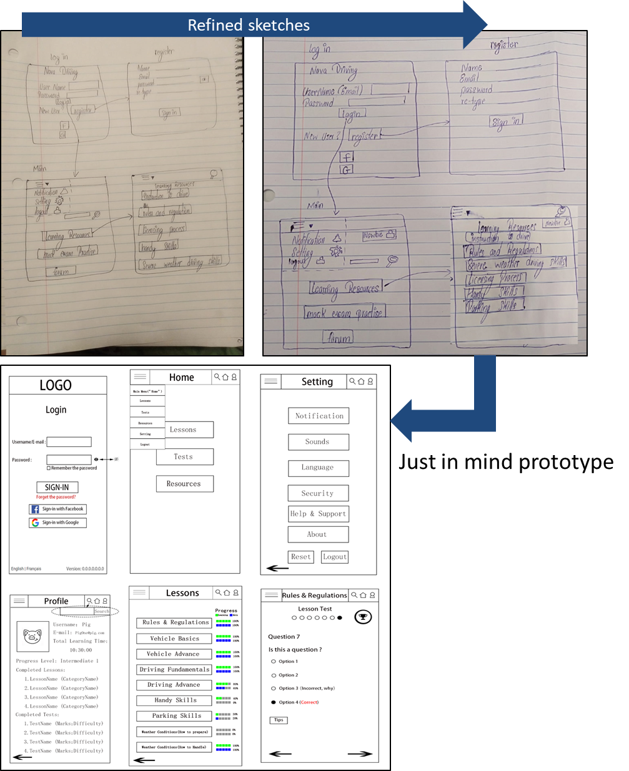



Figure : Final Design Progress

# Usability study design

## Study design goals and objectives

Nova Driving’s core goal is to provide users with a platform that enhances the learning process of obtaining a driver’s license in Nova Scotia. Building on the momentum gained through the multiple iterations of requirement gathering and refinement in addition to heuristic evaluation; the results were used to enhance and streamline the platform’s design and flow in preparation for prototyping.

A rapid horizontal prototype was developed based on the refined functional, data and usability requirements and recommendations from the heuristics evaluation. The next phase of the design thinking process is to test the prototype - starting with usability testing. The overarching purpose of usability testing is to identify and further explore all user responses and experiences with the platform’s usability specifically the main functionality groups:

**General system functionality:** navigation, login/sign-up, search, etc.

**Core features:** lessons, tests and resources

Following the definition of ‘usability’ from Rubin and Chisnell (2008):

*“The user can do what he or she wants to do the way he or she expects to be able to do it, without hindrance, hesitation, or questions.”*

A multi-pronged and user-centric approach was applied to test the platform and address the following objectives:

1. Identify bugs and issues with functionality and usability
2. Assess the platform’s accessibility specifically the platform’s navigation, logical flow, structure, layout and overall design
3. Identify instances of confusing experiences and evaluate the platform’s ease of use and user-friendliness

## Methodology

Rooted in informing the design of the final product and helping identify and eliminate user frustration, the usability testing phase will focus on conducting the appropriate tests and gathering the associated data to identify and then rectify usability deficiencies in our existing design and prototype. Using a hypothesis-based approach, the following four components underpin the design methodology and are discussed in detail in the following section:

* Test participant selection
* Test plan
* Test cases

Figure : Usability Categories

* Data analysis plan

**Study design hypotheses:**

Three main hypothesis categories were developed and integrated into our study design to test the usability of the platform as portrayed in Figure 10.

Hypothesis testing will be applied based on the details in Table 5 for each hypothesis category and follow the following steps:

1. Specify the null and alternative hypothesis
2. Set significance levels
3. Calculate the test statistics and corresponding p-value

Test participant selection

A total of 2 testing participants will be selected to conduct the usability study. Finding the right participants for the test is a critical component, the selection criteria should ensure testers are selected and are representatives of the solution’s target audience and match the persona defined in the Design Thinking: Ideation Workshop. Therefore, a screening protocol will be applied to ensure participants are aligned with our testing plan and methodology. Based on this, the testing participants should have the following characteristics:

* International students or new comers to Canada and/ or Nova Scotia
* Does not have a Nova Scotia Driver License but intends to attain it

Recognizing the iterative nature of the testing phase in addition to the resource, time and other costs associated with testing, a representative sample size of 5 testers will be used to conduct the usability testing study.

## Test plan

The testing study plan sets out the components and protocols required for conducting the usability study as outlined in the table below:

|  |  |
| --- | --- |
| **Test Plan Component** | **Description and purpose** |
| **Type of test** | Between-subjects study design will be applied were all 5 testing participants will test a single and consistent user interface using an identical test plan and testing method. The remaining components and protocols help ensure the required experimental controls are in place to create identical testing conditions for each participant and usability test session. |
| **Test settings and conditions** | Testers will be observed in a controlled setting as they perform a series of tasks defined by a standardized set of test cases. Figure 2: test step (below) depicts the test settings were the testers will be provided with an interactive prototype on one laptop and the test details on a second laptop that will be supervised by the moderator. |
| **Test method and logistics** | A three-phase approach is used to conduct the test study which consists of:   1. Test participant screening 2. Initial introduction and brief synopsis 3. Usability testing session |
| **Data collection and evaluation measures** | * Number of clicks * Time taken to complete tasks and each test scenario * Error rates (pass/ fail) |
| **Testing moderator and observer roles and responsibilities** | Multiple members of the design and development team will be present during the tests and fulfill the following roles and responsibilities:   1. Main test moderator 2. Product and technical expert (lead prototype designer) 3. Note taker #1: number of clicks 4. Note taker #2: error rates and user sentiment 5. Time keeper |
| **Test script**  **(opening remarks and instructions)** | Testing session orientation and onboarding to provide the tester with the appropriate context, test session instructions and information about the platform, its purpose and the study design. |

Table : Summary of Usability Test Components

Details and specifics on each element within the usability testing plan above are included in appendix C.

# Analysis results and discussion

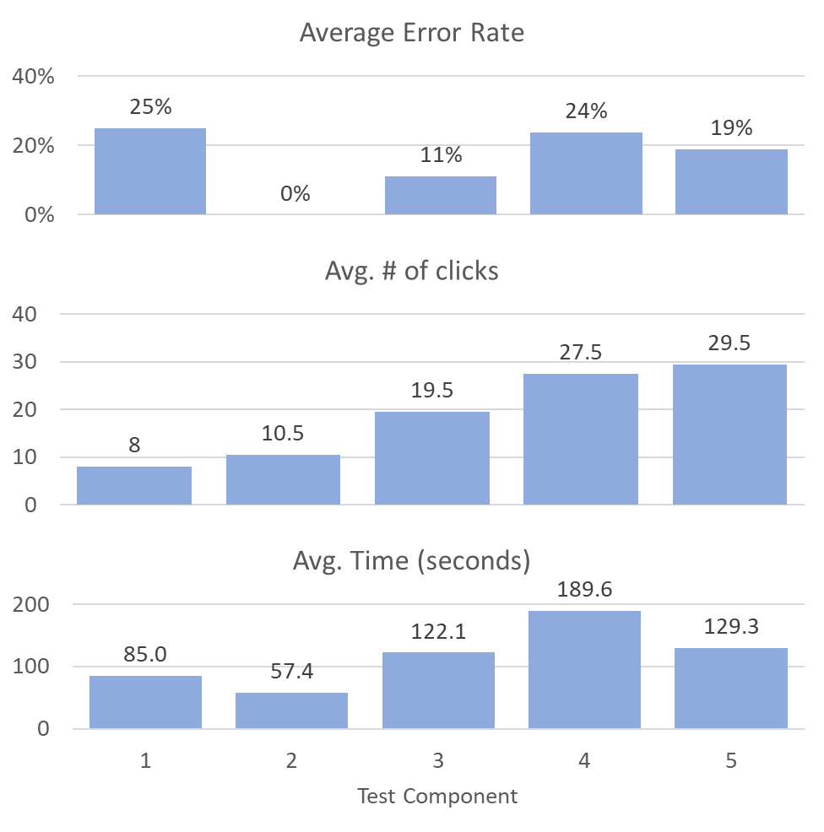

Figure : Preliminary (Peer) Test Results

## Results of usability testing

The test plan was conducted on two peer testers and two outside testers using the same protocols, testing templates and data collection procedures to gathering an initial set of test results.

The testing template also handles the data capture, consolidation and high-level analysis of the results as shown in Figure 5.

Keeping the main goal of the app in mind, scientific calculations are performed using empirical statistics on our design to measure whether we are in the right direction of fulfilling the purpose. To research on the degree of benefit, friendly environment and simplicity of the app, three hypotheses have been designed.

* Measurement of the degree of benefit achieved by attempting to answer the testing question and tasks – Is the app efficient?
* Measurement of the user friendliness that is achieved by looking into the testing question – Is there any relationship between user experience and different types of the screens of the app? In short, is the friendliness lost while switching from one type of screen to the other?
* Measurement of the degree of simplicity is achieved by solving the question – Is the degree of user interaction uniform across the app’s screens and features? As a user moves from one screen to the other, new design should not increase complexity for the user.

Hypothesis Tests along with results:

## Category – Efficiency

|  |  |
| --- | --- |
| **Category** | **Efficiency** |
| **Claim** | Does user become efficient in using the app as he/she spends more time using the app? |
| **Null hypothesis (H₀)** | Mean time taken by user in Home Screen >= Mean time taken by user in Login Screen |
| **Alternative hypothesis (H₁)** | Mean time taken by user in Home Screen < Mean time taken by user in Login Screen |
| **Required Metrics** | |
| * Efficiency will be measured by the time consumed by the user to complete testing for a screen. * Average of total time taken by multiple users will be considered for each screen. | |

All the logical process flows are considered and then each pair of screens are compared for efficiency. We have the following t-test (one-sided tail) for the two-sample test for each pair of screens feasible in the logical process flow. For every test, the average time taken by all the users for each test scenario of every screen are considered.

**Assumptions**

* + Users have similar cognitive skills.
  + Users are interacting with the app for the first time.
  + User experience is uniform across the platform. (Proved later)
  + User interaction is uniform across the design. (Proved later)

### Login vs Home

The process flow considered is when the user logs into the system and access the home page. To test this process flow, the following represents the hypothesis test and the associated results:

**H₀:** Average time take by user on the login screen (μ(login)) is less than or equal to the average time taken by user on the home screen (μ(home)).

**H₁:** Average time take by user on the login screen (μ(login)) is more than the average time taken by user on the home screen (μ(home)).

**Proof:**

* **Level of significance:** 0.05 (i.e. confidence coefficient of 95%)
* **Degree of freedom:** 7=3-1+6-1, where the number of scenarios for the login page is 3 and number of scenarios for the home page is 6
* **T- statistic used:**

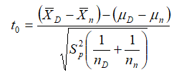

Equation : Efficiency T-Statistic

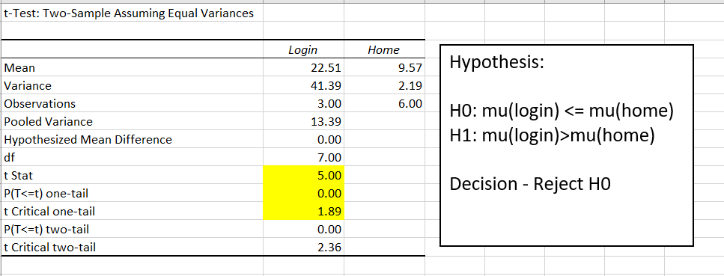

Figure : Login vs. Home Hypothesis Testing Results (part 1)

Microsoft Excel’s embedded Data Analysis tool was used to calculate the results.

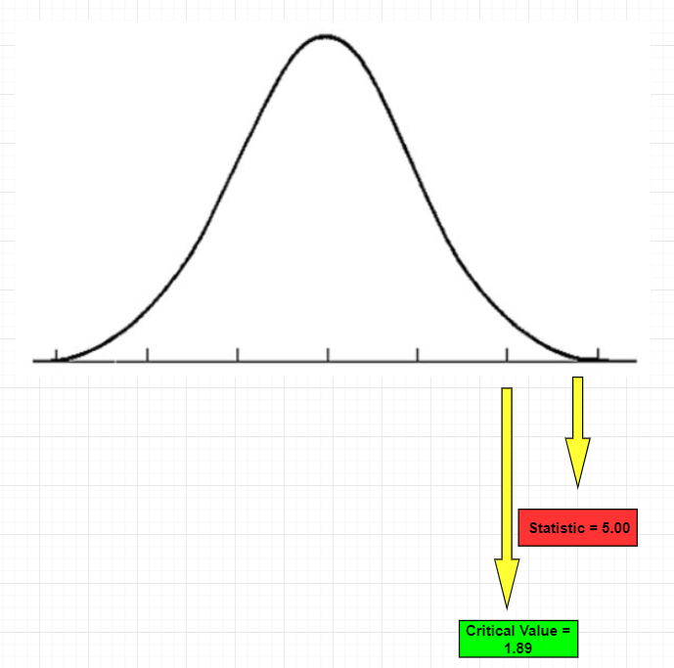**Analysis:**

Figure : Login vs. Home Hypothesis Testing Results (part 2)

Since t-statistic > the critical value, clearly it lies in the rejected region. Also, the p-value = 7.82 x 10-4 is far less than the significance level of 0.05. Hence, with strong evidence the null hypothesis is rejected.

**Decision:**

When user moves from login page to home page then the efficiency increases.

### Remaining test and summary

Following on the same pattern and analysis flow, the remaining categories were tested in the same manner. The table below outlines the conclusion of all the tests. For further details refer to appendix D.

Based on the all possible navigation, we have the efficiency matrix as shown below:

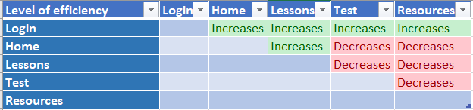

Table : Testing Efficiency Matrix

**How to read this table?**

Example – If we consider the 2nd row for Home screen and 3rd column for Lessons screen, the level of efficiency is “increases”. The interpretation is as a user moves from the home screen to the lessons screen, his/her efficiency increases. The level of time spent for lessons screen is lesser after using the home screen.

**Is the app efficient?**

There is no one line answer to this question. As we can see from the above matrix, the user’s efficiency increases as he/she spends more time with the app until the test and resources screens are encountered. But given the functional requirements of test and resources features in the app, it is expected that a user will spend more time in these screens when compared with login, home and lessons screens.

The area of concern is when the user consumes less time in test and resources screens than the login screen. It signals that the designer’s focus should be on the login screen and may be redesign it so that the user spends less time in login process.

# Summary and Future work

Definitely, the sample data infer that the goals of simplicity and benefit to the users for the purpose of learning how to drive are achieved. But to achieve the goal of friendliness across the application, more work is required for designing the login, test and resources screens.

This may be achieved by conducting surveys where specific questions related to these screens may be asked to the user. For example, how many questions does a user want to practice on in a test? Also, research should be performed to study these kinds of screens from other existing and popular applications. Efficient technical tools can be adopted to design such screens.

Now we have created the prototype version of the application, in the future we need to develop a fully functioning web or mobile app, so that the user can use and interact with our application. Due to the time constraints, our application is limited to only giving information about traffic rules and regulation, conducting tests and providing link to different resources, but we are unable to simulate the driving environment so that the beginner can get some driving experience in simulated environment before going for actual driving test. For now, our application is bound to Nova Scotia traffic rules and regulation only. Different state of Canada has different traffic rules. In the future version of our application we will try to include traffic rules and regulation and processes of entire Canada. Next thing we want to do is that we want to add forum for discussion between the admins and the users, so that we are able to know different issues faced by the users and Improve our existing version according to it. This forum will work as feedback for future improvements.

# References

Gibbons, S. (2016). Nielson Normal Group: Design Thinking 101. Retrieved from: <https://www.nngroup.com/articles/design-thinking/>

Neilsen, J. (1994). 10 Usability Heuristics for User Interface Design. Retrieved from <https://www.nngroup.com/articles/ten-usability-heuristics/>

Rubin, J. and Chisnell, D. (2008). Handbook of Usability Testing: How to Plan, Design, and Conduct. Effective Tests.

# Appendices

Content:

1. Design Thinking Workshop
2. Detailed functional requirements
3. Usability test design details
4. Usability test analysis and results

# Appendix A – Design Thinking Workshop

## Empathy results

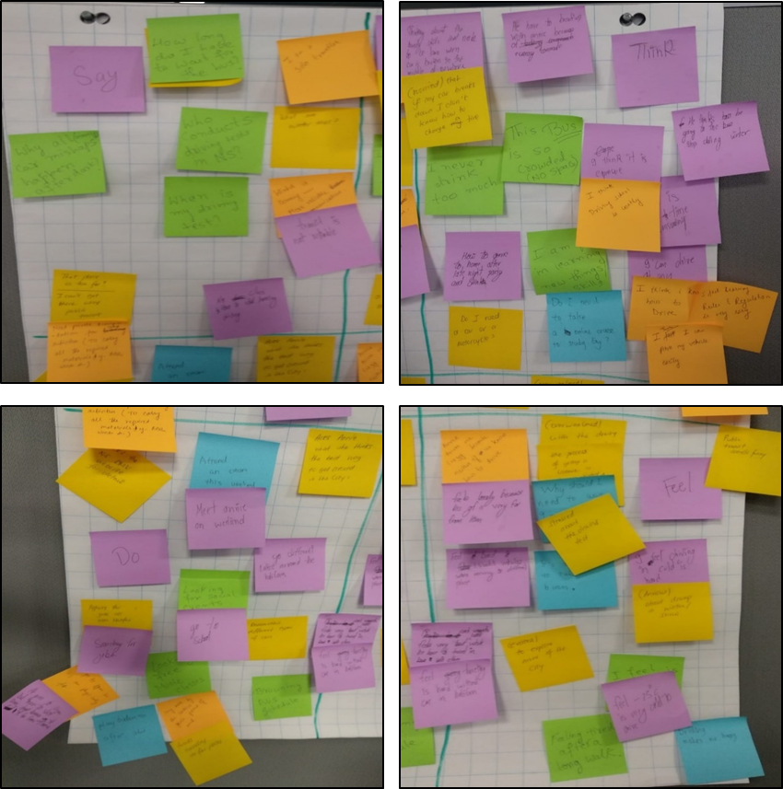

## Summary of needs

|  |  |  |  |  |
| --- | --- | --- | --- | --- |
| Steps | Commute | Social + recreational activities | Plan (license + learning Info) | Work + study |
| Doing | 1. Browsing bus schedule. 2. If late, takes cab (expensive). 3. Public transport is time consuming. | 1. Play badminton after school. 2. Looking for free nearby music classes. 3. Go different lakes around Halifax 4. Attend a concert this weekend. | 1. Researches different types of cars. 2. Checks the DMV website for details (authorized website). | 1. Searching for Jobs. 2. Go to school. |
| Thinking | 1. This bus is so crowded. 2. Do I need a car or motorcycle. 3. I can't drive at any condition. 4. Why all car mishaps happen after dark? 5. He finds it difficult to go to bus stop during winter. | 1. How to come home after late night parties and drink? 2. I never drink too much. | 1.Taking driving school is costly and time consuming. 2. Thinks learning rules and regulation is easy. 3. I think I need to watch online videos. | 1. Do I need to take online course to learn English? |
| Feeling | 1. Public Transit is not reliable. 2. feel difficult to travel in public transit. | 1. To explore parts of the city. 2. Feel tired after a long walk. 3. Drinking makes me happy. | 1. Why should I need to wait 9months for getting my Driving license? 2. Anxious about driving in winter and snow. 3. stressed about the driving test. 4. Find difficulty when traveling to different place. | Anxious about driving in winter/snow. |

# Appendix B – Detailed functional requirements and heuristics

## Group 1: Functional requirements

| **Group 1** | | | |
| --- | --- | --- | --- |
| **Functional requirement** | | **ID#** | F1 |
| System must enable the user to login to their account | | | |
| **Sub-functional requirements** | | | |
| **F1.1** | Sign in operation must include user inputs: (1) username/ email and (2) password | | |
| **F1.2** | Sign in operations must include pre-authorized login from the same device after the first initial login | | |
| **F1.3** | Sign in operations must include an option for assistance with credential recovery in case the user is unable to access their account (refer to F2 for new user operations) | | |
| **F1.4** | System must display an error and prompt users when incorrect credentials are entered | | |
| **F1.5** | System must lock user account based on 10 failed login attempts within an hour of first and last attempt | | |
| **F1.6** | Sign in screen must include language selection options to allow users to select their preferred language setting | | |
| **F1.7** | Language preferences must be linked to the user’s account and profile, such that with each successful login, the platform loads in the user’s preferred language | | |
| **Data requirements** | | | |
| **F1-D1** | Account data table should include account details for each user | | |
| **F1-D2** | account data table should include user email addresses to allow credential recovery via email | | |
| **F1-D3** | Account login attempt data table to track user login attempts | | |
| **F1-D4** | Language preference must be included in the user profile data table | | |
| **User interface requirements** | | | |
| **F1-UI1** | Flags should be displayed based on user language selection | | |
| **Functional requirement** | | **ID#** | F2 |
| System must enable the users to sign-up for new accounts | | | |
| **Sub-functional requirements** | | | |
| **F2.1** | System must provide user with the option to ‘sign up’ from the sign in screen | | |
| **F2.2** | Registration for new account shall be supported by Facebook and Google account registration | | |
| **F2.3** | Registration operation shall prompt users to input the following fields: • Email (required field, input mask validation) • Name (required field, length requirement) • Password (required field, length and character type combination required) | | |
| **F2.4** | System must display error and highlight issues with entry form | | |
| **F2.5** | Sign in must include language selection options for allow users to select their preferred language | | |
| **F2.6** | Language preferences must be linked to the user’s account and profile, such that with each successful login, the platform loads in the user’s preferred language | | |
| **F2.7** | System must validate email address upon successful registration | | |
| **Data requirements** | | | |
| **F2-D1** | Account data table should enable checking if user email address is already in use | | |
| **F2-D2** | Language preferences must be included in the user profile data table | | |
| **User interface requirements** | | | |
| **F2-UI1** | Required fields should have an asterisk with reference below | | |
| **F2-UI2** | Error messages should display the exact issue (e.g. password composition or complexity requirements not met, email already in use) | | |
| **Security requirements** | | | |
| **F2-S1** | Password composition requirements should include characters and numbers and a minimum length of 8 characters | | |
| **Functional requirement** | | **ID#** | F3 |
| System must start at the Home page (landing) on each “launch” after successful login or authorized access | | | |
| **Sub-functional requirements** | | | |
| **F3.1** | Home page must display button to link to platform settings, search function and profile | | |
| **F3.2** | Home page must include all the platform’s features that are available for the user including (lessons, tests and resources) – refer to each group 2 section below for detailed functional requirements on each feature | | |
| **F3.3** | User must be able to access and navigate to and across lessons, tests and resources from the side menu using navigation buttons (refer to user and interface requirement) | | |
| **F3.4** | User must be able to resume progress from any platform resource from their last access point (e.g. resume at the last lesson or question) – further details in each section of the feature’s functional requirements. | | |
| **Data requirements** | | | |
| **F3-D1** | User progress should be tracked in the user progress table | | |
| **Functional requirement** | | **ID#** | F4 |
| System must allow users to access the platform’s main sections from the platform’s side menu | | | |
| **Sub-functional requirements** | | | |
| **F4.1** | System must include menu button to allow access to the pop-up side menu | | |
| **F4.2** | Log out button should be clearly displayed and easily accessible from the side menu | | |
| **F4.3** | System must maintain user preferences | | |
| **Data requirements** | | | |
| **F4-D1** | Data requirements: user settings should be linked to use profile table | | |
| **Functional requirement** | | **ID#** | F5 |
| System must provide access to a help and support page from the settings menu | | | |
| **Sub-functional requirements** | | | |
| **F5.1** | User must be able to get access to the support page and FAQ | | |
| **F5.2** | The support page should enable the user to submit tickets and report issues – optional | | |
| **Functional requirement** | | **ID#** | F6 |
| System must include and allow access to the search function | | | |
| **Sub-functional requirements** | | | |
| **F6.1** | System must provide a text input field when user clicks on the search icon | | |
| **F6.2** | User must be able to submit keywords or phrases for search | | |
| **F6.3** | System must provide a list of findings based on keywords using the device’s resource search database | | |
| **F6.4** | System will display results based on keyword searches, each result should link to the appropriate menu or screen | | |
| **Functional requirement** | | **ID#** | F7 |
| System must allow users to access their profile page from the platform’s side menu or the profile button: | | | |
| **Sub-functional requirements** | | | |
| **F7.1** | Once a user logs in, a person icon is maintained at the top of every screen next to home button and search button. | | |
| **F7.2** | When clicked on the icon, a window pops up displaying user’s name, email address and progress level which represents a measurement of user’s completed lessons and tests. In short, it displays the degree of knowledge that the user has gained from our application. | | |
| **Functional requirement** | | **ID#** | F8 |
| System must allow users to access the platform’s settings from the side menu or the profile button | | | |
| **Sub-functional requirements** | | | |
| **F8.1** | Notification – It will have the collection of all notifications addressed to the user. The user should be able to disable/enable notifications. | | |
| **F8.2** | Sounds – User can enable or disable sound options or control the volume level for the application. | | |
| **F8.3** | Language – User can set his/her preferred language. | | |
| **F8.4** | Security – In this section, user can change password | | |
| **F8.5** | Help & Support – It provides the help & support service, and the documents of the app. | | |
| **F8.6** | About – It describes the development team of the app, and contact information | | |

## Group 2A: Lessons functional requirements

|  |  |  |  |
| --- | --- | --- | --- |
| **Group 2A** | | | |
| **Functional requirement** | | **ID#** | F1 |
| System must allow users to access the various lessons from the lessons menu based on progress | | | |
| **Sub-functional requirements** | | | |
| **F1.1** | System must display progress of each lesson based on two status types (reviewed materials and completed the lesson quiz) | | |
| **F1.2** | Lessons past the current available lesson will be locked and greyed out, access to these lessons will be disabled | | |
| **F1.3** | User must be able to navigate back from the current lesson to the lesson menu | | |
| **F1.4** | Each lesson will contain 2-N pages | | |
| **F1.5** | Each page will contain various information bubbles that will require the user to press each on to review | | |
| **F1.6** | Bubbles will change color once reviewed (yellow to grey) | | |
| **F1.7** | User will not be able to navigate to the next page within the lesson until all information bubbles are reviewed | | |
| **F1.8** | Once all information bubbles and pages are reviewed, the system will provide the user with the option to (1) take the lesson test or (2) navigate back to the lesson menu | | |
| **User interface requirements** | | | |
| **F1-UI1** | To minimize screen clutter and maximize usability, only one information bubble pop-up can be viewed at one time. The user can select the bubble’s close button or press on the surrounding area to exit the current bubble | | |
| **Functional requirement** | | **ID#** | F2 |
| System must allow users to access the lesson test from the ‘lesson complete’ menu | | | |
| **Sub-functional requirements** | | | |
| **F2.1** | At the end of every lesson, an user is given with two options – “Want to take a test?” (a link is provided), clicking on the link will take the user to the lesson test screen corresponding to the completed lesson. The other option is the “finish” button. If the user wants to skip the test and finish the lesson, he/she should click on finish button. | | |
| **F2.2** | If the test option is selected, the user will be prompted with 5-N multiple choice questions related to the topic, user can select ¼ options (radio button) and then click the submit button to submit the answer | | |
| **F2.3** | System will check the answer against the lesson test database. If the answer is correct, the user will be prompted with a “Correct” answer prompt, otherwise an “Incorrect” answer prompt will appear. If an incorrect answer is selected, the user will be provided with a ‘skip question’ option or have the ability to select a different answer | | |
| **F2.4** | Once all answers are selected, the system will display a table containing the results of the lesson test based on user input. | | |
| **F2.5** | System will display results based on incorrect, correct and skipped questions. | | |
| **Data requirements** | | | |
| **F2-D1** | Data requirement: lesson test database will include questions and answer sets for each lesson | | |

## Group 2B: Tests functional requirements

|  |  |  |  |
| --- | --- | --- | --- |
| **Group 2B** | | | |
| **Functional requirement** | | **ID#** | F1 |
| System must allow users to access the test from the menu: To make the system worthy learning, it must be interactive from both ends – the system as well as the user. Therefore, a platform must be provided to the user where the user can test his/her knowledge that he/she has learnt though the system and access a feedback to evaluate his/her grasp about the “learning to drive” process. The knowledge test will be designed in the following manner to achieve the goal described aforesaid. | | | |
| **Sub-functional requirements** | | | |
| **F1.1** | When the user clicks on the “Test”, two options must be provided to the user viz. “Practice Mode” and “Time mode”. | | |
| **Functional requirement** | | **ID#** | F2 |
| Practice mode – system must allow users to access the “Practice mode” from the test menu, there will be no time limitation for the user. The user is free to take as much as time to study and answer a question. | | | |
| **Sub-functional requirements** | | | |
| **F2.1** | There will be 3 options for the level of questions – easy, intermediate and hard. | | |
| **F2.2** | Easy questions are meant for users who are novice to the system | | |
| **F2.3** | Intermediate questions are useful for those users who are intermediate and have covered at least the first 5 lessons in feature #1. | | |
| **F2.4** | Hard questions are useful for expert level of users who have studied at least 10 lessons in feature #1. These questions are similar to the real-life questions that are faced by Nova Scotia license seeking aspirants | | |
| **F2.5** | Users have the freedom to move around any of the 3 options irrespective of the level of lessons, they have covered in feature #1(lessons). | | |
| **F2.6** | For a particular question, the user has a right to look for solution without answering the question. | | |
| **F2.7** | For a particular question, the user has a right to skip without answering the question. If the user exits a question (under any mode) without answering the question but later, while his/her login session is active and he/she clicks on the “Test” option, then he/she should be redirected automatically by the system to this unanswered question. This feature will be useful, if the user reads a question and want to look for the answer in the lesson (feature #1). He/she can go back to the lesson, fetch the answer, come back to this question as the system will preserve the state of the movement of the user and then the user can attempt to answer the same question. This will minimize user’s efforts in looking for the same question. May be later, we can perform statistics on this feature as how efficiency increases for the sake of usability and make the system perform better when compared with other systems. | | |
| **Functional requirement** | | **ID#** | F3 |
| Time mode – system must allow users to access the “Time mode” from the test menu, there should be a time limitation for the user. The user is bound to answer a set of questions within a stipulated time limit. | | | |
| **Sub-functional requirements** | | | |
| **F3.1** | There will be 3 options for the level of questions – easy, intermediate and hard. In addition, the system must ask for the length of time – options will be 10 mins, 30 mins and 60 mins. | | |
| **F3.2** | Easy questions are meant for users who are beginners to the system. The system will ask 10 questions under 10 mins option, 25 questions under 30 mins option, 40 questions under 60 mins option. | | |
| **F3.3** | When the user answers the question, there will be a countdown to remind the user of the remaining time. | | |
| **F3.4** | Intermediate questions are for those users who are intermediate and have covered at least the first 5 lessons in feature #1. A user cannot access this feature unless he/she has completed the first 5 lessons. The system will ask 8 questions under 10 mins option, 20 questions under 30 mins option, 30 questions under 60 mins option. | | |
| **F3.5** | Hard questions are for expert level of users who have studied at least 10 lessons in feature #1. A user cannot access this feature unless he/she has completed the first 10 lessons. The system will ask 5 questions under 10 mins option, 15 questions under 30 mins option, 30 questions under 60 mins option. | | |
| **F3.6** | Once the time or the test is over, the system must provide the feedback/statistics about the user’s results such as – total no. of questions, no. of questions answered correctly, no. of questions answered incorrectly, no. of questions (out of total) completed, no. of questions (out of total) not completed (due to running out of time). The system will provide a link where all the solutions are provided to the set of questions answered by the user. In this link, the user will be given an option to rate each of the questions (1 to 5). This will help the system to build a popularity chart for all the questions in the database. In short, the difficulty level of a question will be influenced by the user’s popularity ratings. | | |
| **F3.7** | The system should save the progress of answering the questions of the user for both test modes. The progress should be highlighted with a progress bar. the progress bar will consist of mix of green and white parts. The green part of the bar will represent the proportion of questions that an user has completed and the white part will symbolize the proportion of questions yet to be completed by the user. | | |
| **F3.8** | A user’s progress level will increase as he/she completes answering the questions. The increments will be rapid with higher difficulty level of questions answered by the user in shorter frequency of attempts. | | |
| **F3.9** | Each question (under each mode) will be displayed along with a rating (1 to 5 represented by asterisks) showing the popularity of the question among the users. | | |
| **F3.10** | The database of questions under practice mode and that of time mode should have an intersection not more than 20 percent of the total (union) no. of questions. | | |

## Group 2C: Resources functional requirements

| **Group 2C** | | | |
| --- | --- | --- | --- |
| **Functional requirement** | | **ID#** | F1 |
| System must allow user to access the additional materials either through internal or external resources within the platform resource menu. | | | |
| **Sub-functional requirements** | | | |
| **F1.1** | Once the resource option in the main menu is selected, the system will display the resource submenu. | | |
| **F1.2** | The resource submenu will contain two main options, the “Licensing Process” and the “Video Repository”, and a “Back” arrow. | | |
| **F1.3** | Once the “Licensing Process” option is selected, the system will display a new page with a sub-menu, and a “Back” arrow. | | |
| **F1.4** | The screen under the “Licensing Process” menu will contain all the procedures for applying for a driver's license, material preparation etc. | | |
| **F1.5** | Once the user clicks on the external web link, a warning window pops up to inform the user that the link is navigating the user to content outside the app. This window will alert with the message "This content will navigate you out of the application. Do you want to continue?". If the user agrees then the system navigates the user to their default browser and open the link content they asked for, otherwise "Cancel" will keep the user interface in the page before they clicked the external link. | | |
| **F1.6** | Once the “Video Repository” option is selected, the system will display a new page with a video classification menu, and a “Back” arrow. | | |
| **F1.7** | The homepage of the “Video Repository” displays an input field located in the middle of the top of the page for search function. | | |
| **F1.8** | This sub-page displays the most popular video categories for users, and the most popular videos for users which contains a thumbnail on the top of its title and description. | | |
| **F1.9** | Once the user clicks on a video’s title or its thumbnail, a warning window pops up to inform the user that the title and the thumbnail of the video is navigating the user to the YouTube application or external environment. This window will provide two button options, one is “Keep navigating” which will keep navigate the user to the YouTube application or its default browser, and the other is “Stay in the Nova Driving” which will keep the user interface in the page before they click on the video title or its description. | | |
| **F1.10** | Users can see the history of recent viewings on every page of resources (limited to 5). | | |
| **Data requirements** | | | |
| **F1-D1** | All provided videos are stored in the video database as external web links. | | |
| **F1-D2** | Track and record the query history and viewing history of all users and save them in the database. | | |

## Heuristic evaluation results summary

Table : Heuristic Evaluation Results Summary

|  |  |  |  |
| --- | --- | --- | --- |
| **Evaluation Criteria** | | **Overall Average Score** | **Consolidated Rationale** |
| **1** | **Visibility of system status** | 2.6 | * Buttons are unclear * Registration screen does include the option to sign up using Google or Facebook accounts * Navigation and flow between screens is unclear |
| **2** | **Match between system and the real world** | 1.8 | * Lack of navigation buttons * Forum is no longer a feature of the platform * Missing account registration buttons |
| **3** | **User control and freedom** | 2.0 | * No exit from search function * Lack of logical links and clear navigation between functions and features |
| **4** | **Consistency and standards** | 4.0 | * Search button not consistent between screens, redesign based on unified and standardized format of each screen |
| **5** | **Error prevention** | 1.0 | * Registration required fields are missing * Information on password composition and requirements are missing |
| **6** | **Recognition rather than recall** | 4.4 | * Mostly simple layout but needs more simple and descriptive icons and buttons to guide users |
| **7** | **Flexibility and efficiency of use** | 4.4 | * Provides functionality to register using other accounts |
| **8** | **Aesthetic and minimalist design** | 4.6 | * Minimalistic and simple design, minor adjustments and redesign needed to side menu |
| **9** | **Help users recognize, diagnose, and recover from errors** | 1.8 | * Forget password function is missing |
| **10** | **Help and documentation** | 1.0 | * Help, FAQ and documentation is missing |

## Logical Process Flow



Figure Logical Process Flow

# Appendix C - Usability testing details

## Test method specifics

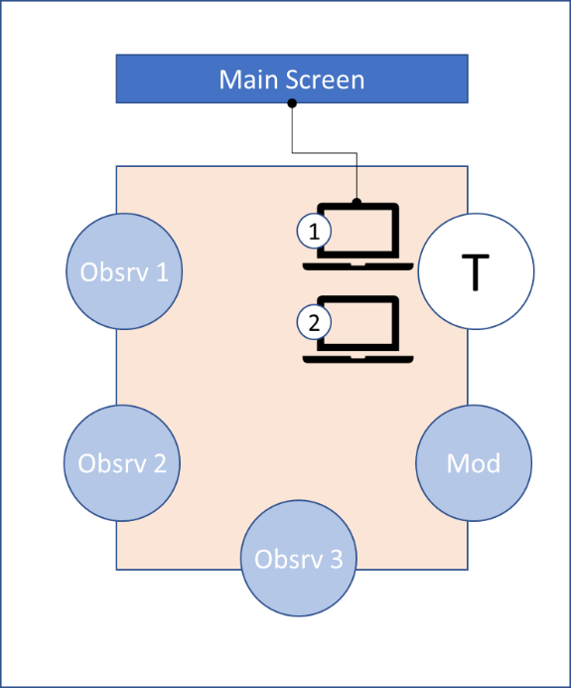

Figure : Testing Setup

* **Test participant screening**

To ensure the test participant satisfies the participant selection criteria as detailed in the previous section, the participant will be asked the following brief questions prior to starting the next phase of the test method:

Question 1: Are you an international student?

Question 2: Do you have a Nova Scotia driver’s license?

Question 3: Do you intend on getting a licence to drive in Nova Scotia?

* **Initial introduction and brief synopsis**

Prior to starting the usability testing session, the test moderator will start with a brief introduction on the test protocols, the prototype, the expected results of test and the type of data being collected by the testing team.

The participant will be asked to think and read out load to enable the members of the testing team to record and track results and progress during the test session.

* **Subsequent usability testing session**

The testing session will include the following steps:

* + Provide user with the prototype with the relevant preconditions for each test case
  + Provide user with additional screen for steps and instructions
  + Collection of qualitative and quantitative results and measurements

## Test scenarios and cases

Testing scenarios have been built around the 5 main components of the platform:

1. Login and sign-up functionality
2. Access and navigation to and across the platform’s components from the home page
3. Access and navigation to and within the lessons components
4. Access and navigation to and within the test component and the various modes within
5. Access and navigation to the resources and the associated content within

Each platform testing component listed above include one or more testing scenarios that are broken down further into logical test cases with associated steps and expected results/ success criteria as outlined in Figure 4 the test template and Table 3.

|  |  |
| --- | --- |
| **Test template elements** | **Description and purpose** |
| **Test scenario breakdown and details** | |
| **Test Scenario** | Describe the platform component being tested. |
| **Test Case** | Describe the component being tested. |
| **Precondition(s)** | Describe the conditions that must be observed before testing. |
| **Steps** | Describe the specific steps of an ideal test. |
| **Expected Results/ Success Criteria** | Describe the test results expected when the user completes the test. It will serve as an important basis for comparison with the actual results and determine whether the test results are successful or not. |
| **Results and collected data points (collected for each test session)** | |
| **Status** | Describe whether the test case’s result matches the expected result. If they match, the status displays “Pass”, otherwise it displays “Fail” |
| **Actual Results/ Comments** | Describe the actual results of the test case when the tester tests the test case, and the tester's comments on the result. |
| **Number of clicks** | Describe the number of clicks the tester needs to complete the test case |
| **Time taken** | Describe the length of time the tester takes to complete the test case |

Table : Testing Data Collection Template



(Link to full version)

## Data analysis plan

**Methodology of proof**

* Each hypothesis will have a well-crafted list of assumptions which will be tested statistically.
* The appropriate test model (comparing means) will be used to infer the results for the platform and state the reason behind the selection
* The default level of significance will be 0.05 (i.e. confidence coefficient will be 95%)

**Expected Results**

* Rejection/acceptance of the hypotheses
* An upper triangular efficiency matrix for the logical flow of user experience from one screen to another. For this, we will conduct the efficiency test for each pair of screens.

**Metrics to be used as input for testing**

* Time taken by testers to complete the usability testing cases
* Click count performed by testers to complete the usability testing cases
* Percentage of pass/ fail for each usability testing case
* Qualitative measures will be used based on the captured tester sentiments about the user experience

## Test script

**[Introductions to the testing team]**

**[Brief intro about the platform]**

Thank you for taking the time to participate in this study. Before we begin, let us walk you through why we are here today. Our team is designing a platform to help international student and new comers to Nova Scotia learn how to drive in the Province by providing the necessary learning requirements with adjustable language preferences and through a visual and interactive manner.

**[Go over the consent form details]**

**[Study screening questions]**

To participate in the study, we will ask you three short screening questions to make sure you fit the study design criteria.

Question 1: Are you an international student?

Question 2: Do you have a Nova Scotia driver’s license?

Question 3: Do you intend on getting a licence to drive in Nova Scotia?

**[Brief intro on the test purpose and setup]**

We will give you a brief overview of the test and how it will work. Here we will give you a broader task to complete and then will ask questions as we go along.

Before we proceed towards the task, we would like to give you a little bit overview of the context behind it, such as why you might be doing it and what you will achieve from it. We are only testing the website and not you, so feel free to respond while performing the test. Please feel free to let us know if you like or dislike something, or if you are confused while performing test.

Please feel free to let us know if you are not feeling comfortable to perform test and you can stop at any particular time of the test. Also, we would like you to "think aloud" as much as possible, so that we can note down your point of view.

**[Go over data collection protocols]**

My team members will be collecting data in few different forms:

1. Timing to complete each task
2. Number of clicks
3. Noting down your overall experience as you go through
4. Note down a pass or fail of the test based on how the prototype functioned in the test

All data collected will be used in aggregate form only. Your name is only required on the consent form, other than that no personal or identifiable information will be collected or stored. If at any point you have questions, please don’t hesitate to ask. Do you have any questions so far?

# Appendix D – Usability Test Results

### Home vs Lessons

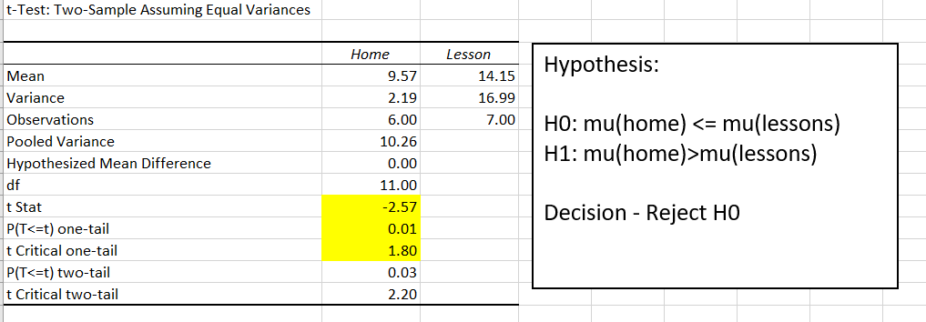

Figure : Home vs. Lessons Analysis Results

**Decision:**

When user moves from home page to lessons page then the efficiency increases.

### Login vs Lesson

From 1 and 2 and using transitivity property, we can conclude that when user moves from login page to lessons page then the efficiency increases.

### Lessons vs Test

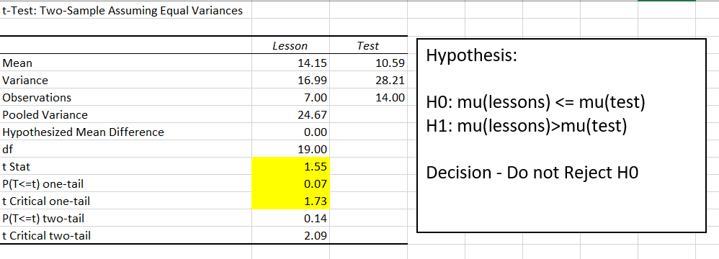

Figure : Lessons vs. Test Analysis Results

**Decision:**

When user moves from lessons page to test page then the efficiency decreases.

### Home vs Test

Figure : Home vs. Test Analysis Results

**Decision:**

When user moves from home page to test page then the efficiency decreases.

### Login vs Test

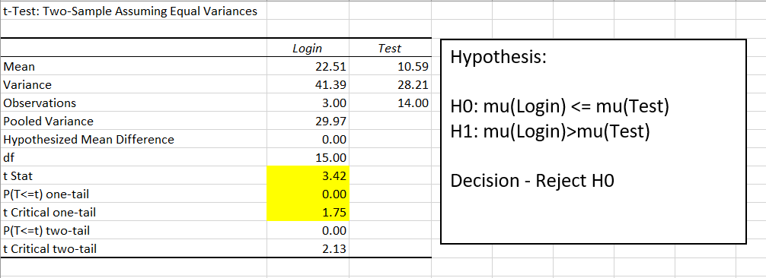

Figure : Login vs. Test Analysis Results

**Decision:**

When user moves from login page to test page then the efficiency increases.

### Test vs Resources

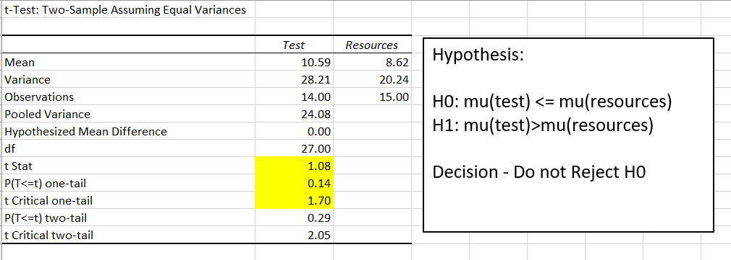

Figure : Test vs. Resources Analysis Results

**Decision:**

When user moves from test page to resources page the efficiency decreases.

### Lessons vs Resources

**Decision:**

By transitivity, when user moves from Lessons page to Resources page then the efficiency decreases.

### Home vs Resources

**Decision:**

By transitivity, when user moves from Home page to Resources page then the efficiency decreases.

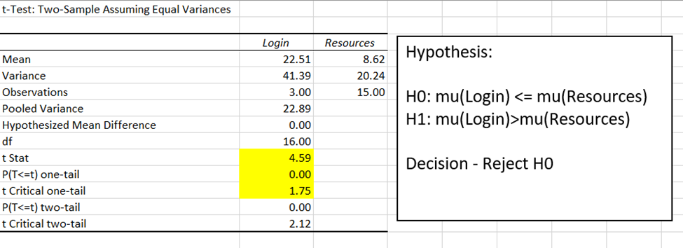

Figure : Home vs. Resources Analysis Results

**Decision:**

When user moves from Login page to Resources page then the efficiency increases.

## Category – Dependency

|  |  |
| --- | --- |
| **Category** | **Dependency** |
| **Claim** | Is there any relationship between user experience and the screens of the app? |
| **Null hypothesis (H₀)** | There is no relationship between user experience and screens. |
| **Alternative hypothesis (H₁)** | There is a relationship between user experience and screens. |
| **Required Metrics** | |
| * User experience will be measured by a uniform weighted average of the time consumed by the user and count of clicks performed by the user to complete testing for a screen. * Multiple users must be considered. | |

**Definition:** Degree of User Experience is defined as a uniform weighted average of the time taken by the user and the number of clicks performed by the user to complete a set of objectives.

We are performing chi-square test for the contingency table and checking for the independence condition.

* **Level of significance:** 0.05 (i.e. confidence coefficient = 95%)
* **Degree of freedom:** 4=(5-1)*(2-1) where the number of screens (r) is 5 and the number of users (c) is 2
* 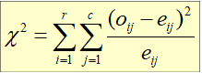**Chi-square- statistic used**

Equation : Dependency Chi-square Statistic

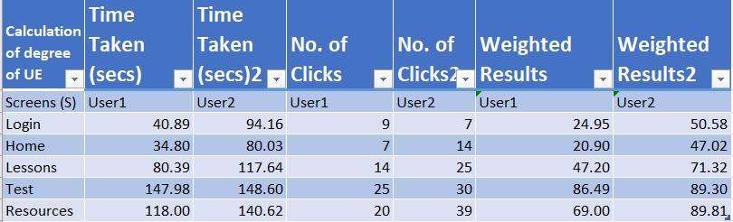

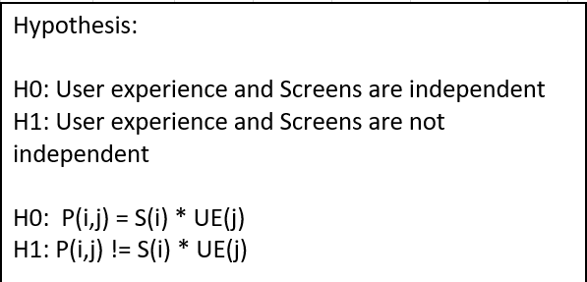

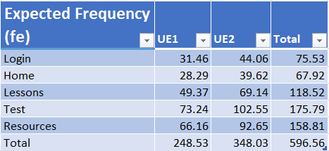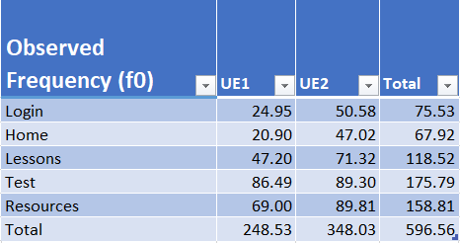

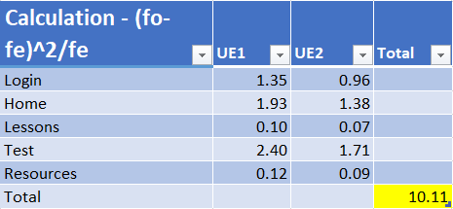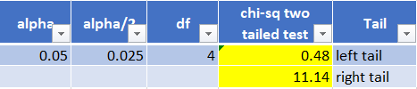

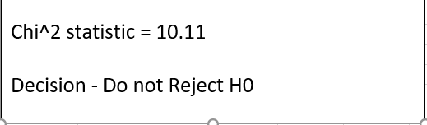

**Decision:**

Do not reject H0 i.e. User experience is independent of the type of screen. Here, the possibility of Type-I error is 5%.

## Category - Uniformity

|  |  |
| --- | --- |
| **Category** | **Uniformity** |
| **Claim** | Is the degree of user interaction uniform across the app? |
| **Null hypothesis (H₀)** | There is no relationship between the degree of user interaction and design of screens. |
| **Alternative hypothesis (H₁)** | There is a relationship between the degree of user interaction and design of screens. |
| **Required Metrics** | |
| * Degree of user interaction will be measured by a uniform weighted average of the count of clicks performed by the user to complete testing for a screen and no. of interactive elements part of design of the screen. * Multiple users must be considered. | |

**Definition:** Degree of User Interaction is defined as a uniform weighted average of the number of interactive elements present in the design and the number of clicks performed by the user to complete a set of objectives.

We are performing chi-square test for the contingency table and checking for the independence condition.

* **Level of significance:** 0.05 (i.e. confidence coefficient is 95%)
* **Degree of freedom:** 4=(5-1)*(2-1) where the number of screens (r) is 5 and the number of users (c) is 2
* **Chi-square statistic used**

Equation : Uniformity Chi-square Statistic

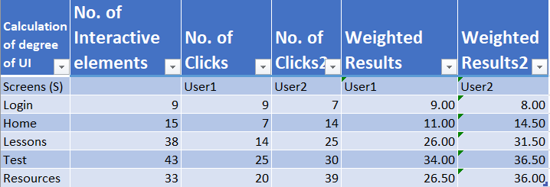

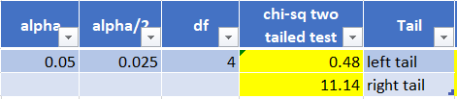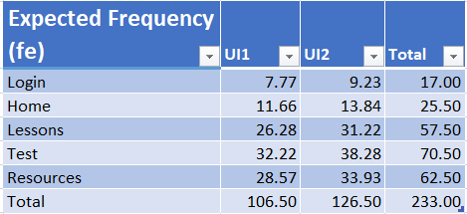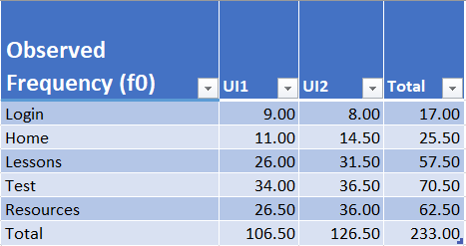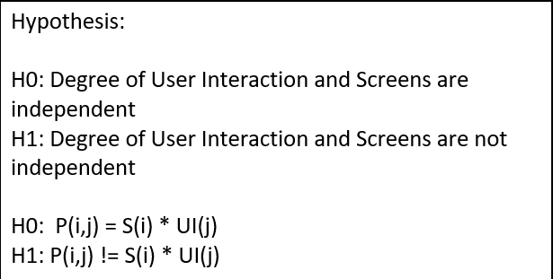

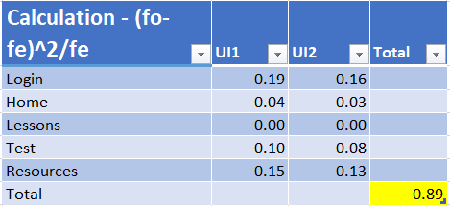

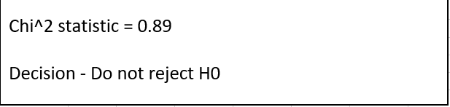

**Decision:**

Do not reject H0 i.e. Degree of user interaction is independent of the type of screen. Again, the possibility of Type-I error is 5%.